1. **Two kinds of testing**:
2. 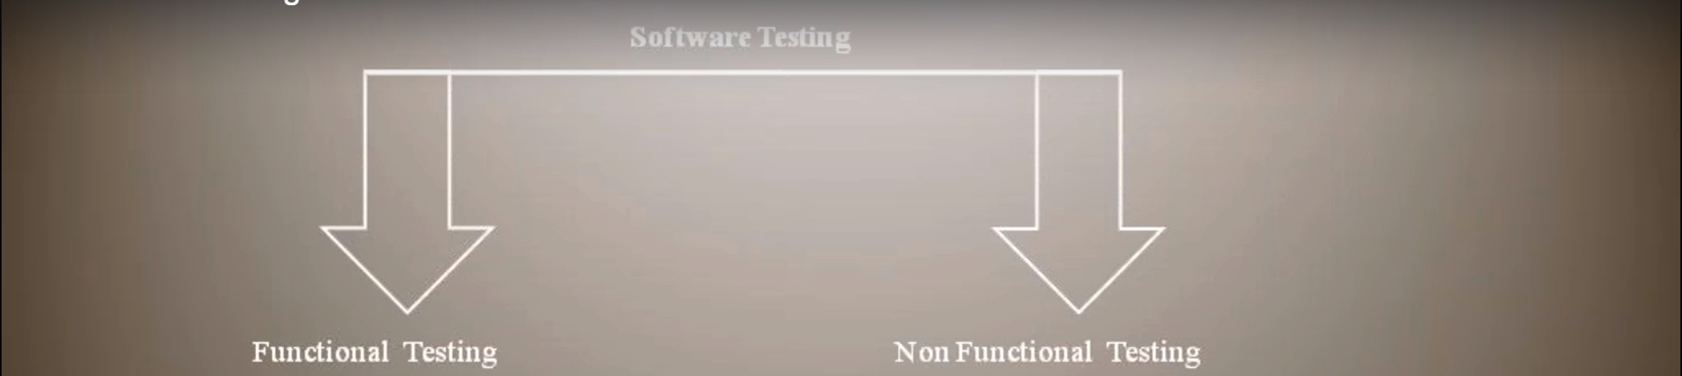
3. **Functional Testing Example**:  
   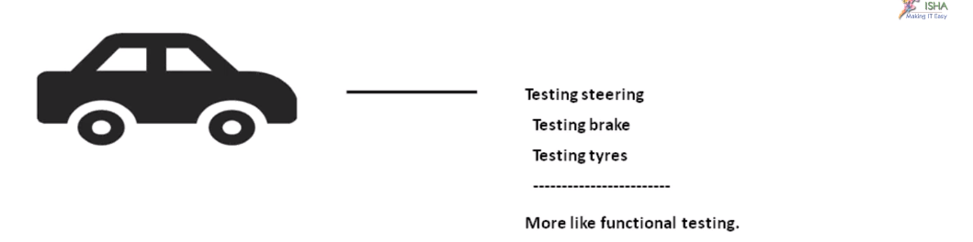
4. **Non-Functional Testing**:  
   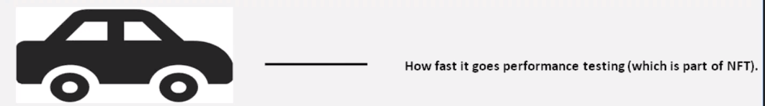**NOTE**: Performance testing is Non-Functional testing.
5. **AUT/SUT**: **A**pplication (S) **U**nder **T**est.  
   No matter what kind of testing, we are doing either Manual Testing, Automation Testing, Performance Testing, Security Testing etc.
6. Let us take Gmail App to understand Functional/Functionality Testing and Non-Functionality Testing.
7. The below is functional testing where we are checking if login functionality is working fine when giving right or wrong credentials.   
   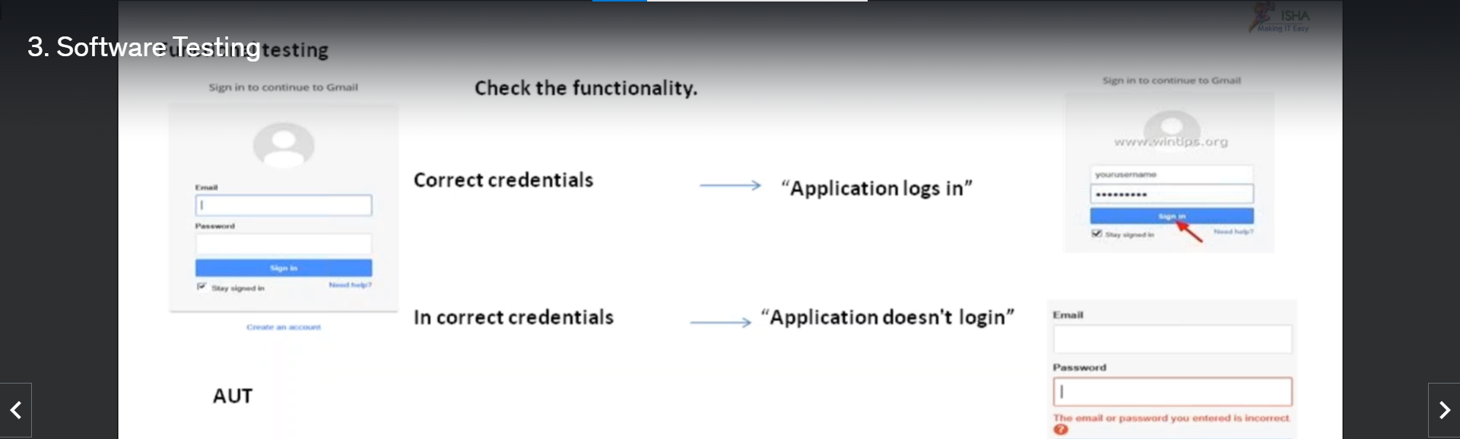
8. **Non-Functional Testing**: When checking how fast application login it is, is called **Performance Testing** which comes under **Non-Functional Testing**.
9. **Performance Testing**:
   1. The demand is high in US.
   2. Ration: Manual Testers : Performance Testers 🡺 10 : 3
   3. Salary Package is high.
   4. A little bit easier as compared to Manual testing.
   5. **Pre-requisites**: A little about
      1. Programming.
      2. DB.
      3. Servers,
      4. Architectures.
      5. Etc.
   6. 20 to 30 kinds of testing comes under PT.   
      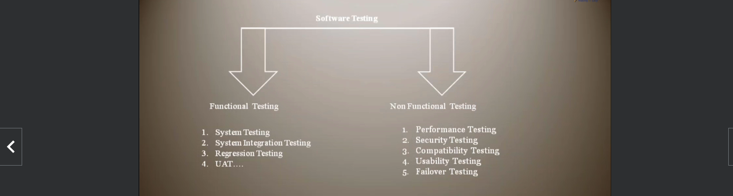
   7. Security Testing:
      1. How safe a transaction is.
      2. How safe the Credit Card details of a customer.
      3. How safe his login details.
      4. There are different tools for that as well.
      5. Penetration Testing falls under Security Testing.
10. Many Tools for Performance testing.
    1. **LoadRunner** (LR): Very Popular (80% of Market Share) by **MicroFocus**. Earlier by HP and earlier by Mercury till 2009.
       1. **Frameworks under LoadRunner**
          1. **Performance Center.**
          2. **StromRunner Load.**
    2. **Rational Performance Tester** (RPT) by IBM.
    3. **Microsoft VSTS**.
    4. **JMeter** Open Source by Apache.
    5. **NEO Load.**
    6. **Web Load.**
    7. **OATS : Oracle Application Testing Suite**
11. **Terminology**:

|  |  |
| --- | --- |
| **A Deviation from a Requirement is called** | |
| **Terminology** | **Testing Area** |
| Bug or Defect | Functional Testing |
| Bottleneck | PerformanceTesting |
| Vulnerability | Security Testing |